**Experiment # 02**

**OBJECTIVE:**

To become familiar with different searching techniques in arrays

To become familiar with linear search

**Theory:**

**Searching Techniques in Arrays:**

Searching is a process of finding the required data in the array. Searching become more important when the length of the array is very large .

**Linear or Sequential Search:**

Sequential search is also called linear search it is a simple way to search the array for the desired value .

**Algorithm for Linear Search:**

* Visit the first element of the array and compares its value with the required value.
* If the value of the array matches with the desired value,the search is complete.
* If the value of the array does not match move to next element and repeat same process .

Loop are frequently used to visit elements of array for searching a value. You can start the counter variable of loop from 0 and move it to last index of array. For example if the array to be searched has10 elements, the loop will start the counter variable from o and move to 9.

**EXAMPLE:**

Develop a Code that initializes an array .it inputs the values from the user and searches the number in array .

#include<iostram.h>

#include<conio.h>

Void main()

{

Int arr[3]={10,20,30};

Int I,n,loc=-1;

Cout<<”Enter value to find:”;

Cin>>n;

For(i=0;i<3;i++)

If(arr[i]==n)

loc=i;

if(loc==-1)

cout<<”Values not found in the array.”;

else

cout<<”Values found at index”<<loc;

getch();

}

**OUTPUT:**

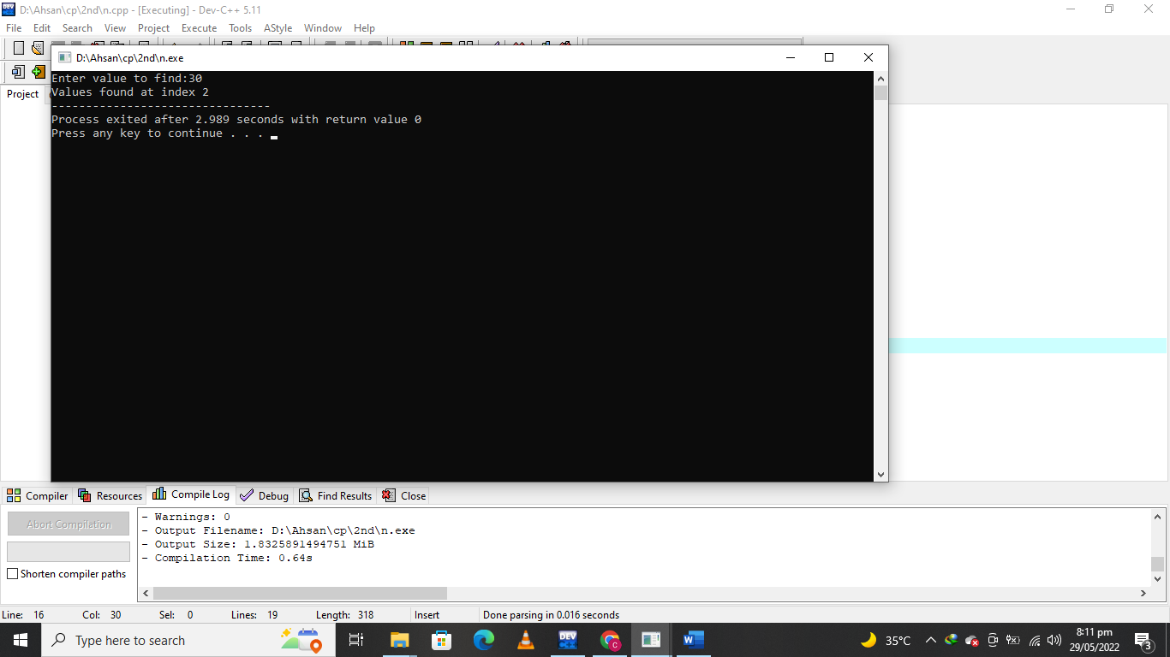

**Lab Tasks:**

**QNo:01 Develop a code in C++ that inputs ten floating point values in an array and apply**

**sequential search technique?**

**QNo:02 Compile and Run the given code.**

**QUESTION NUMBER : 01:**

**Develop a code in C++ that inputs ten floating point values in an array and apply**

**sequential search technique?**

**PROGRAM:**

#include <iostream>

#include<conio.h>

using namespace std;

int main()

{

float f;

float f1[10];

cout<<" Enter the 10 number:";

for(int i=0;i<10;i++)

{

cin>>f;

f1[i]=f;

}

for(int i=0;i<10;i++)

cout<<" The number at"<<i+1<<"index is: "<<f1[i]<<endl;

int temp = -1;

cout << " Please enter an element to search" << endl;

int num;

cin >> num;

for (int i = 0; i < 10; i++) {

if (f1[i] == num) {

cout << " Element found at position: " << i + 1 << endl;

temp = 0;

break;

}

}

if (temp == -1) {

cout << " No Element Found" << endl;

}

}

**OUTPUT:**

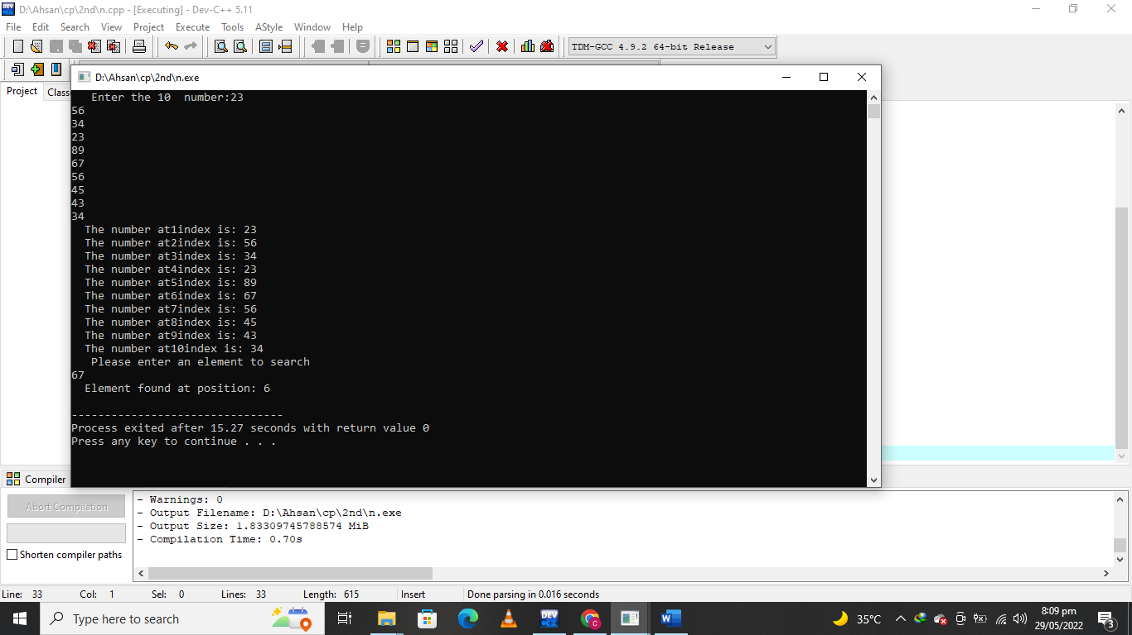

**QUESTION NUMBER : 02:**

**Compile and Run the given code.**

**PROGRAM:**

#include <iostream>

#include<conio.h>

using namespace std;

int main()

{

int arr[3]={10,20,30};

int i,n,loc=-1;

cout<<"Enter value to find:";

cin>>n;

for(i=0;i<3;i++)

if(arr[i]==n)

loc=i;

if(loc==-1)

cout<<"Values not found in the array.";

else

cout<<"Values found at index "<<loc;

getch();

}

**OUTPUT :**

